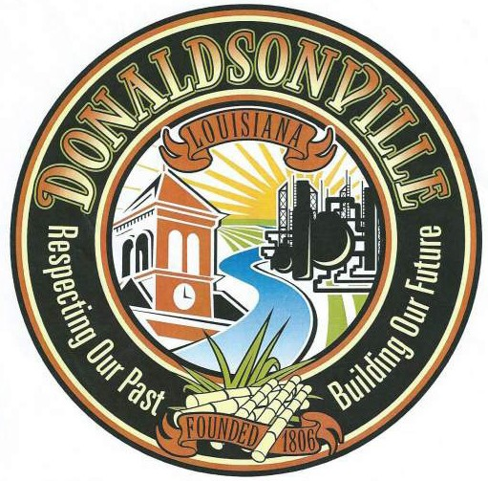

City of Donaldsonville
P.O. Box 470 Donaldsonville, LA 70346
Phone (225) 473-4247 • Fax (225) 473-0630

Date of Request

Applicant Name:

Property Address:

Contact Number #:

Legal Description:

Flood Hazard Boundary Maps, PANEL NUMBER 22005C0200E Dated August 16, 2007
Zone
City Sewer Commercial
City Gas Residential: Inside City Limits Outside City Limits)
Contractor Historic District Approval / NA
Flood Zone Demolition (Dumpster Required)
Generator Installation Mobile Home Allowed / By Petition

Approval for Electrical Occupancy Permit
Approval for the Issuance of a Building Permit
Temporary Municipal for Certificate of Occupancy to be Issued at Your Discretion
Final Municipal for Certificate of Occupancy to be Issued at Your Discretion

Comments:

____________________________________
Applicant Signature Date

____________________________________
City of Donaldsonville Authorized Signature Date

