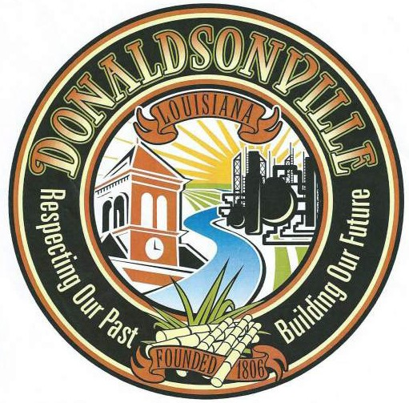
City of Donaldsonville
P.O. Box 470 Donaldsonville, LA 70346
Phone (225) 473-4247 • Fax (225) 473-0630

Historic District Commission Application for a Certificate of Appropriateness
Date Received Application expires six (6) months from date received.

Sec. 1
Residential
Commercial
Sec. 2 Alteration: Minor
Major

Sec. 3 Name of Applicant: Telephone #

If commercial, doing business as:

Address:

Email Address:

Sec. 4

Sec. 5
Give location of property if different from above address.

If rental or lease, give name of owner:

Telephone #

Address:

Sec. 6

Sec. 7
General description of each alteration, pictures of structure, and pictures of replacement. General description of signage, material using, wording, size, picture of structure and placement of sign. Attach drawings. (Attach supplemental sheet if necessary.)

What are your long range plans for improvements on this structure or property?

Sec. 8

Sec. 9
Do all drawings, material samples and other items required by the ordinance accompany the application?
Yes No
If not, please explain.

Some alterations require the approval of other agencies. Obtain the signature of the approving officer of these agencies.

Agency
Approval Required
Signature if Alterations Approved

City Fire Marshall
City Building Inspector Power Company
Yes No Yes No Yes No

Sec. 10 Signature of Owner:
Date Telephone #

Signature of Applicant, if different:
Date Telephone #

Signature of Commission Chairman:
Date:
Do the proposed alterations comply with the historic character of the Donaldsonville Historic District?
Yes No
Is the application approved: Yes No
If not approved, give reasons:
Date of construction: Inventory reference number:
Outstanding architectural features:
Date of Hearing:
No
Is the structure of architectural significance: Yes
Sec. 11 To be completed by the Commission.
Date Received: Received by: Was there a hearing: Yes No

